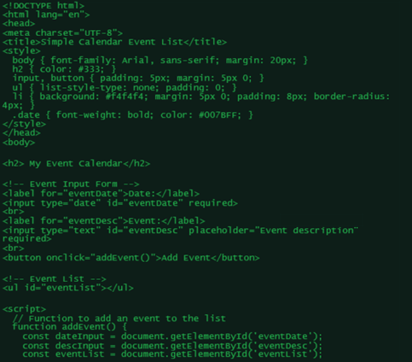

DATA. DELIVERED.


[Insta] burdybirds

[Tiktok]

[Facebook]

[LinkedIn]

[Snap]

[Youtube]

[Web] burdy.co.uk

Trish Burley
Director
[T] +447968730804

[E] burdybusiness@outlook.com

